AGILE:

Agile is a way of managing projects and building software where teams work in small steps, get feedback often, and make changes quickly. The focus is on delivering value to the customer regularly, instead of waiting until the end.

**Key Ideas:**

* Deliver small pieces of work often.
* Listen and respond to changes quickly.
* Work together as a team and communicate openly.
* Keep improving as you go.

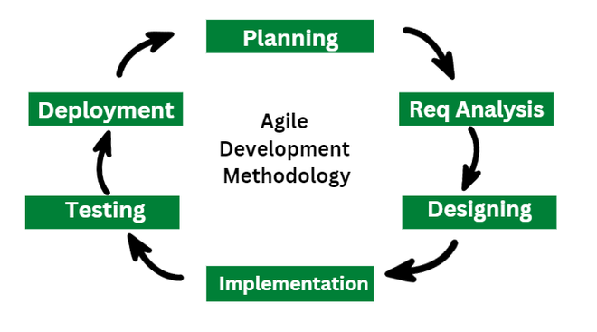

SCRUM:

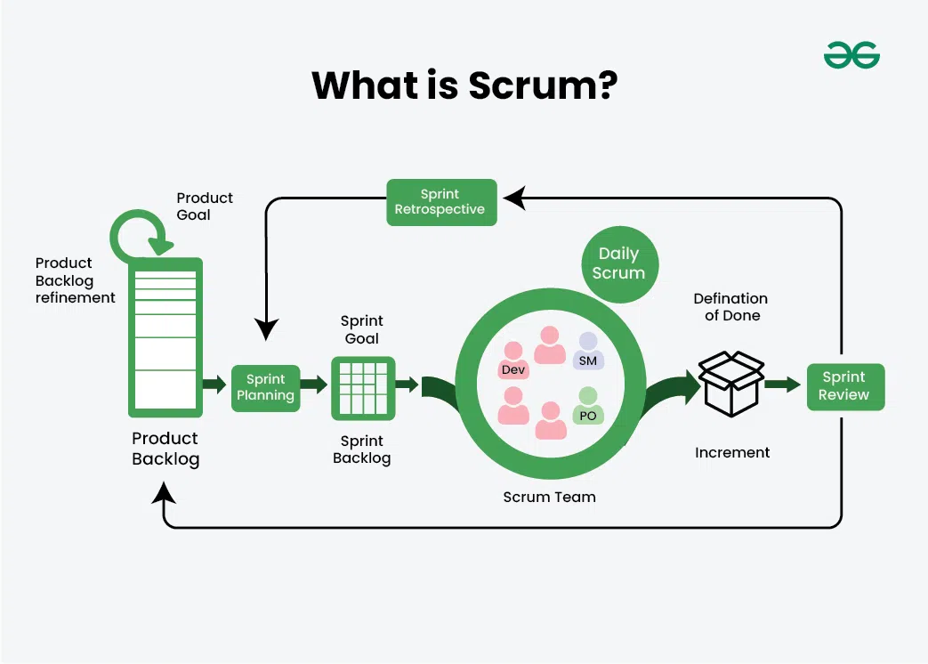Scrum is a framework used in Agile projects. It gives teams a clear way to organize work, track progress, and adapt as needed.

**How it works:**

* Work happens in short cycles called **Sprints** (usually 2–4 weeks).
* Everyone knows what to work on through a **backlog** (a list of tasks/features).
* Team members meet daily to check progress (**Daily Scrum**).
* At the end of each Sprint, the team shows what they built and looks for ways to improve.

**Scrum Roles:**

* **Product Owner** – decides what the team should work on first.
* **Scrum Master** – helps the team follow Scrum rules and removes problems.
* **Development Team** – builds the product.

PRODUCT OWNER:

he Product Owner represents the customer or business. They make sure the team works on the most important things.

**What they do:**

* Make a list of all features and tasks (**Product Backlog**).
* Prioritize tasks – what’s most important comes first.
* Answer questions from the team.
* Accept the work when it meets the requirements.

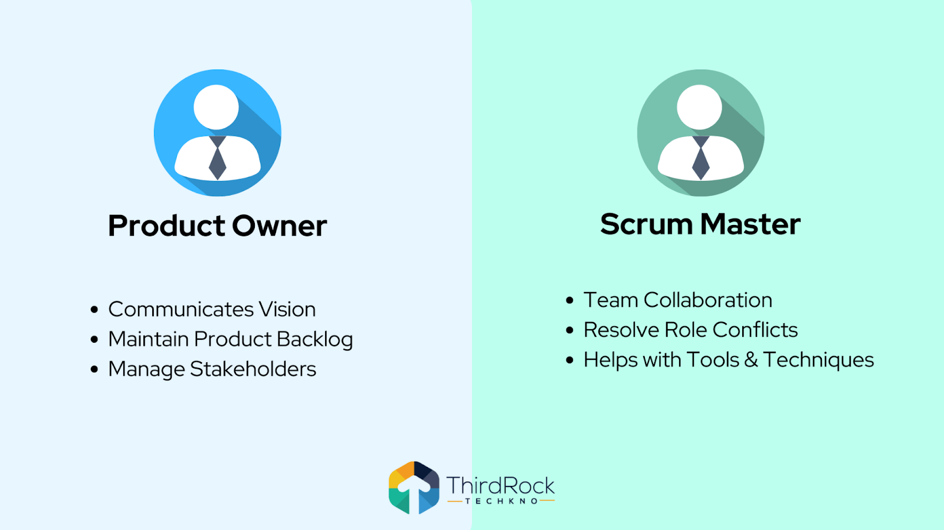

SCRUM MASTER:

The Scrum Master is like a coach or guide for the team. They make sure everyone follows Scrum and help the team work smoothly.

**What they do:**

* Run and guide Scrum meetings.
* Remove obstacles that slow the team down.
* Teach the team how to improve and work better together.
* Protect the team from distractions.

SUMMARY:

| **Term** | **Simple Explanation** |
| --- | --- |
| Agile | A flexible way to work in small steps and adapt quickly. |
| Scrum | A framework in Agile to organize work and track progress. |
| Product Owner | Chooses what the team should work on first. |
| Scrum Master | Helps the team follow Scrum and removes problems. |